1. communication challenges of UAVs have typically been neglected!**Introduction to UAV :**

**UAVs(Unmanned Aerial Vehicles)** popularly known as drones can be used in wireless communication because of their inherent attributes such as mobility, flexibility, adaptive altitude, etc.

Classification of UAV, Regulation :

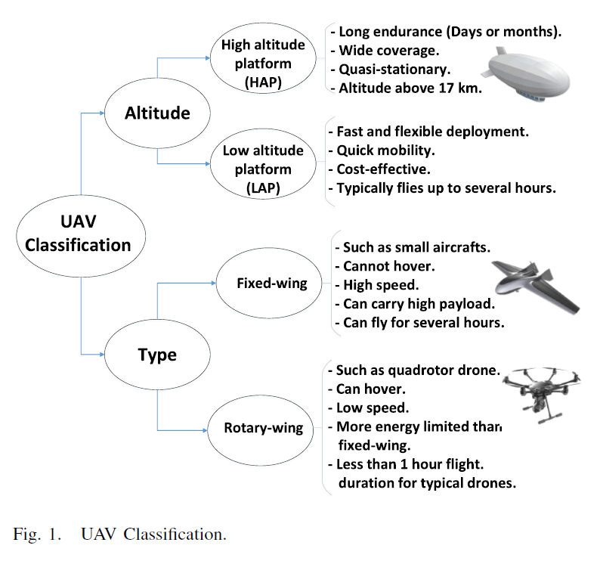

1. **Application :**
2. *UAV Aerial Base Station in 5G and Beyond*

*1. Coverage and Capacity Enhancement of Beyond 5G Wireless Cellular Networks:*

*2.UAVs as Flying Base Stations for Public Safety Scenarios:*

*3.UAV-Assisted Terrestrial Networks for Information Dissemination:*

*4.3D MIMO and Millimeter Wave Communications*

*5.UAVs for IoT Communications:*

*6.Cache-Enabled UAVs:*

1. *Cellular-Connected Drones as User Equipments*
2. Flying Ad-Hoc Networks With UAVs
3. *Other Potential UAV Use Cases*

* *UAVs as Flying Backhaul for Terrestrial Networks:*
* *Smart Cities:*

1. **UAV CELLULAR COMMUNICATIONS IN 5G NR :**

Now let’s discuss UAVs use case in 5G NR. The increasing use of UAVs in various public and industrial applications will lead to a massive amount of data generation and hyper-high bit rates may become necessary in some applications. These UAVs will also require nearly unlimited flight range and strong wireless cellular empowerment to exchange the captured data with ground BSs.

For fulfilling this requirement there are broadly classified two criteria 1) Command and control links and (ii)payload data links

(i) Command and controls :

Let’s see the example of Command & Control,

In order to deliver mail to users' door steps Owners of commercial UAVs can employ controllers to communicate with the UAV, where both the UAV and the controller are 5G-compliant devices. At times, a UAV owner might also be requested to take *direct steering control* of the UAV and that requires UL(Up link) video feedback from the UAV and that dependence on controller is in visual line-of-sight (VLoS) or beyond VLoS (BVLoS).

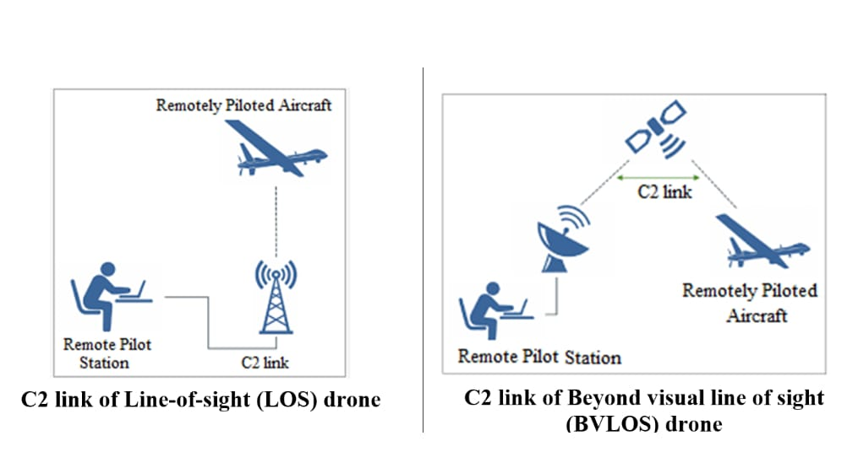

Ty

(ii) Payloads :

UAVs are expected to enable users to experience VR. E.g. through a 360-degree spherical view camera on board, the UAV captures and uploads 8k in real time to a cloud server, requiring a high bit rate and low latency.

Let’s see some NR feature in support of UAV :

(i) LTE / Dual Connectivity :

LTE and NR are bound to coexist in the same geographical area and there are some benefits of that for example, An LTE link operating at lower frequencies could compensate for the link failures that typically occur when NR operates at mmWave frequencies.(E.g. Sudden blockage). And UAVs use much lower UL power than GUE because of LOS propagation conditions that they experience with their serving cell.

(ii) Massive MIMO and mmWave

//we'll see…

1. **UAV CELLULAR SUPPORT THROUGH SUB-6 GHZ MULTI-ANTENNA ENHANCEMENTS :**

Transmission of payload data and for other applications cellular-connected UAVs must access the network. And for this purpose BSs regularly transmit synchronization signal-blocks(SSBs) that facilitate their discovery. For the typical cellular networks are down- tilted BSs, this means that devices flying higher than BSs could only perceive SSB signals through antenna sidelobes.

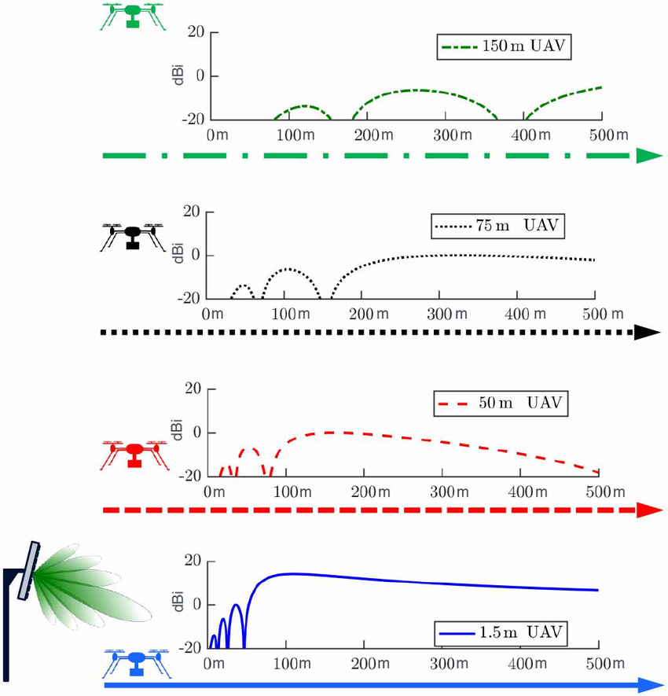

This problem can be solved through NR BSs because it can be transmitted towards multiple directions through time-multiplexed beam sweeping.

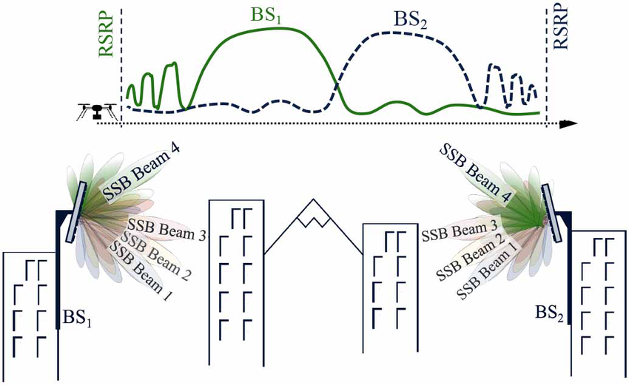

/* The beam formated SSBs introduced in NR can greatly facilitate initial cell selection and subsequent handovers for UAV users, overcoming the power fluctuation issues associated with side-lobes based UAV-BS association.

Once UAVs connect to the network, the latter needs to guarantee a pervasive and sufficient signal quality to enable reliable C2 and data transmissions.

In 5% worst case scenario Massive MIMO are better than Single user (SU) */

Once UAVs connect to the network, the latter needs to guarantee a pervasive and sufficient signal quality to enable reliable C2 and data transmissions.

So Now let’s see some other data transferring method for Interference management

(i) SU

This network consisted of BSs downtilted by 12 degree and equipped with one RF antenna port connected to 8 vertically stacked cross-polarized antenna elements.

(ii) mMIMO

Network with BSs also downtilted by 12 degree but equipped with 128 RF chains connected to an 8 cross 8 planar array of cross-polarized antenna elements. And these are capable of spatially multiplexing up to eight devices.

(iii) aaUAV

UAVs with 2 cross 2 antenna arrays and single RF chain capable of beamforming their UL/DL signals toward/from their servind BSs.

(iv)mMIMOnulls

Massive MIMO BSs capable of placing up to 16 radian nulls toward the most interfering UAVs both during the UL SRS stage and data transmission stage.

Now let’s compare this techniques in UMa and UMi environment :

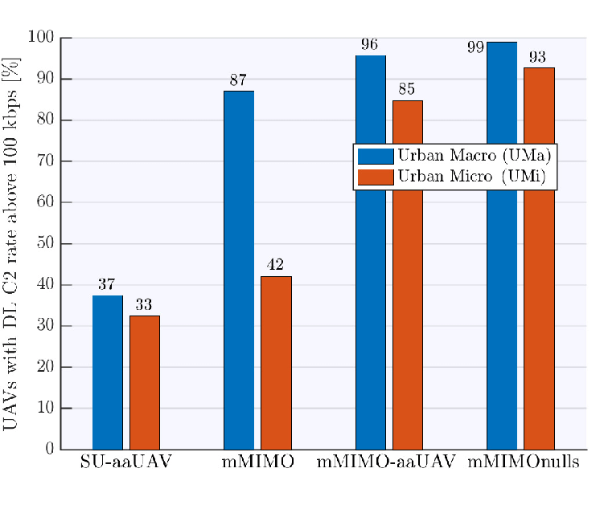

1. **UAV CAPACITY BOOST THROUGH MMWAVE**

So let’s discuss the achievable performance of mmWave-connected UAVs in urban areas.

Aerial coverage depends on the angular and power distributions signal paths along with antenna patterns.

To improve the mmWave communication system, we can introduce the dedicated BS for UAVs.

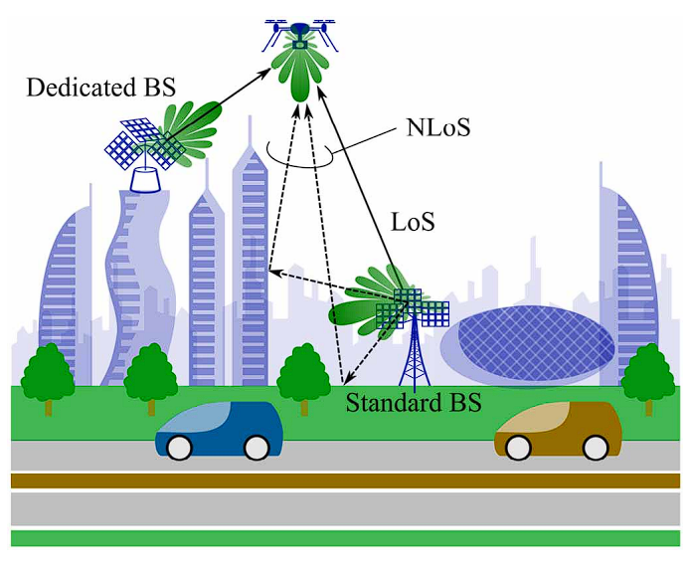

As we can see in the image, the standard BS is tilted downwards to improve the communication system for the GUEs while the dedicated BSs are tilted upwards to improve the LoS communication for the UAVs. As we can see that the probability of LoS communication is much higher for the UAV - dedicated BS communication than the UAV - standard one.

•In this simulation, the LoS links for dedicated cells are written at the bottom of the cell while for the standard cell, it is at the top of the cell.

•The simulation suggests that, at typical urban density, NR mmWave can provide satisfactory coverage to aerial links in spite of down tilted antennasThe simulation suggests that, at typical urban density, NR mmWave can provide satisfactory coverage to aerial links in spite of down tilted antennas, thanks to a favorable combina tion of antenna sidelobes and strong reflections.

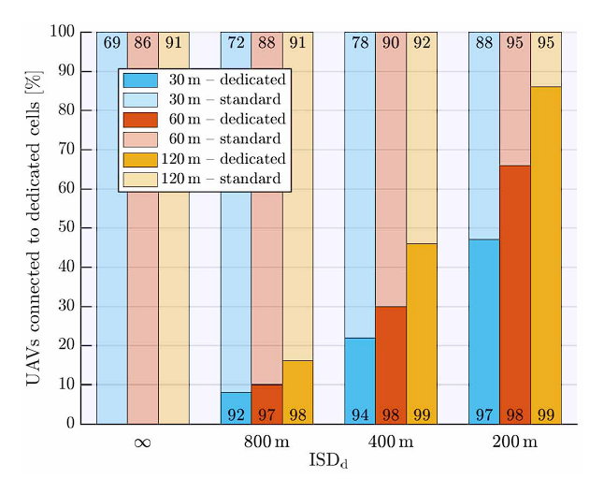

Coverage enhancement with dedicated mmWave BS:

As we can decrease the ISDd, the fraction of the UAVs that connect with the dedicated BSs increases. So we can say that, for lesser ISDd, the UAV prefers to connect with the dedicated BSs rather than standard BSs.

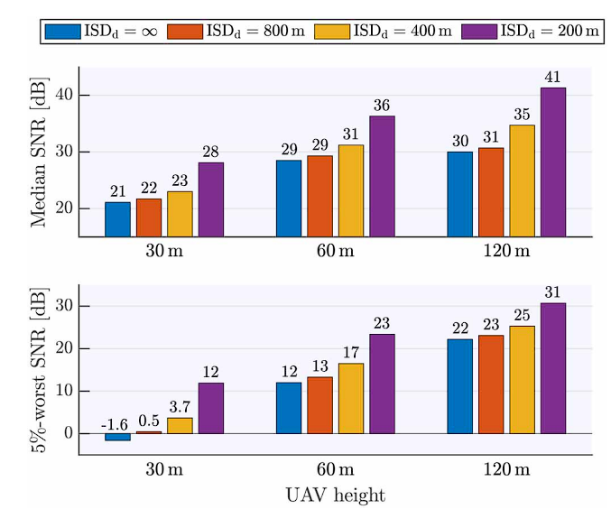

We can see that, we are comparing the SNR of the UAV at different heights and ISDd. We can see that as we can decrease the ISDd, the SNR increases. Also, as we increase the height of the UAV, LoS communication is easier. So, at higher altitude, the SNR is higher compared to the lower altitude.

1. **UAV in 6G**

While 5G is seizing the mmWave band, the 6G will use the higher frequency band between the range 100 GHz to 10 THz.

Due to the reduced diffraction, THz communication is mostly usable in the LoS channel. Which is compatible with the UAVs although we may need a high bit rate for it.

Let’s see an overview of the Non-terrestrial Network, which can be used to replace the standard terrestrial network.

Non-terrestrial network is a network in which all connections go through the flying componentes like HAP, LAP, satellites,etc.

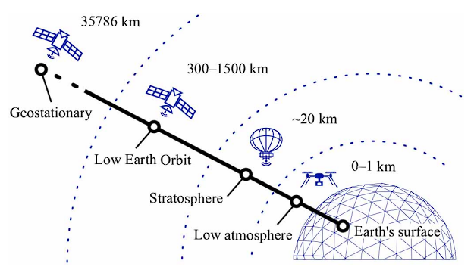

Satellite links are in the geostationary equatorial orbit. As we can see, satellites can reach where cables cannot. They can cover vast areas with LoS coverage. Their links are also resilient to natural disasters on earth. HAPs typically operate in the stratosphere in a quasi-stationary position. HAPs could well complement spaceborne platforms since they are cheapr to launch, can act as wireless relays and achieve acceptable latencies owing to their lower altitudes.

Let’s talk about the UAV to satellite communication:

BVLoS control of UAVs entails zero outage in terms of connection availability as connectivity gaps can jeopardize a UAV mission. The combination of terrestrial and NTN can alleviate this shortcoming by providing blanket coverage of cells ranging from tens of thousands of kms. Recently, such a combination was used in a practical setup for transporting Covid-19 samples and test kits. Integrated terrestrial-NTN avails of a common network management architecture.

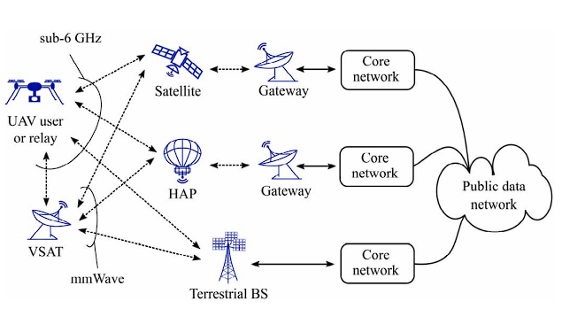

This is a potential architecture for an integrated ground-air-space network, including from the right gateway to air or space feeder links and service links. Depending on the carrier frequency, it can directly serve a UAV or be relayed through a very small aperture terminal(VSAT).

1. **Research**

There are many research topics of research of UAVs in communication systems.

1. **Air-to-Ground Channel Modeling:**

The air-to-ground (A2G) channel characteristics are different from classical ground communication channels, and accurately modeling the A2G channel is important for optimal design and deployment of drone-based communication systems. However, the A2G channel is highly dependent on factors such as altitude, type of UAV, elevation angle, and propagation environment, making it challenging to find a generic channel model. The accuracy of ray-tracing technique for channel modeling is also limited, particularly at low frequency operations. Additionally, any movement or vibration by the UAV can affect the channel characteristics, and the A2G channel is more susceptible to blockage than air-to-air communication links. Overall, comprehensive simulations and measurements in various environments are needed to capture the effects of altitude, antennas' movements, and shadowing caused by the UAV's body in A2G channel modeling.

The A2G path loss model presented in is one of the most widely adopted models for low altitude platforms. The path loss between a UAV and a ground device depends on their locations, the type of propagation environment (e.g., rural, suburban, urban, high-rise urban), and whether the link is Line of Sight (LoS) or Non-Line of Sight (NLoS). As many of the existing literature on UAV communication adopted the probabilistic path loss model. The LoS and NLoS links can be considered separately with different probabilities of occurrence. The probability of occurrence is a function of the environment, density and height of buildings, and elevation angle between UAV and ground device. The ITU-R provides some environmental-dependent parameters to determine the density, number, and height of the buildings (or obstacles) for different types of environments.

The buildings’ heights can be modeled using a Rayleigh distribution as:

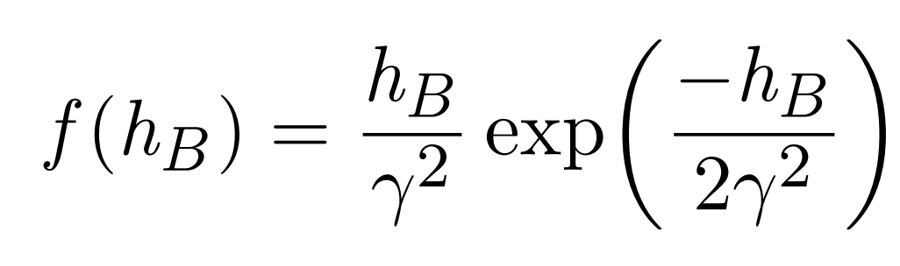

hB = height of buildings in meters

γ = environmental-dependent parameter

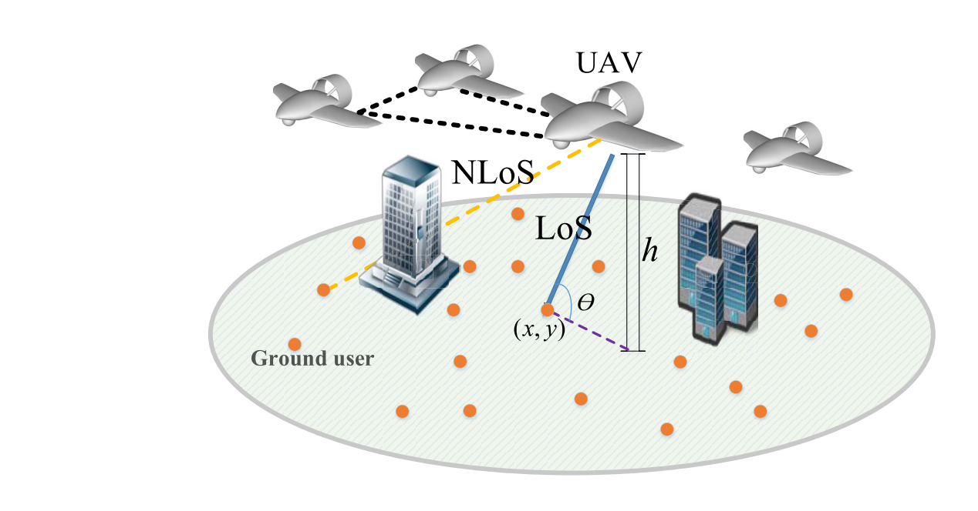

LoS:LoS (Line-of-Sight) refers to a transmission path between a transmitter and a receiver that has a direct, unobstructed line-of-sight between them, with no obstacles in the way.

NLoS: NLoS (Non-Line-of-Sight) refers to a transmission path between a transmitter and a receiver that does not have a direct line-of-sight (LoS) between them, which means the signal is obstructed by an obstacle, such as a building or a hill.

PLoS 1 / ( 1 + C exp(−B[θ − C ] ) )

C and B = Constant value that depend on the environment

(rural, urban, dense urban, or others)

θ = elevation angle

PLoS= LoS probability

This equation shows the probability of having LoS connection between aerial base station and ground users is an increasing function of elevation angle.

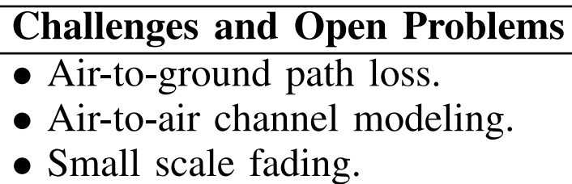

1. Optimal Deployment of UAVs as Flying Base Stations

The three dimensional deployment of UAVs is one of the key challenges in UAV based communication. But the adjustable height and their mobility provide a better opportunity for an efficient deployment. It depends on various factors such as deployment environment, location of ground users, and UAV-to-ground channel characteristics, which are impacted by the UAV's altitude. Multiple UAV deployment also poses a challenge due to inter-cell interference. Unlike terrestrial base stations, UAV deployment requires consideration of flight time and energy constraints.

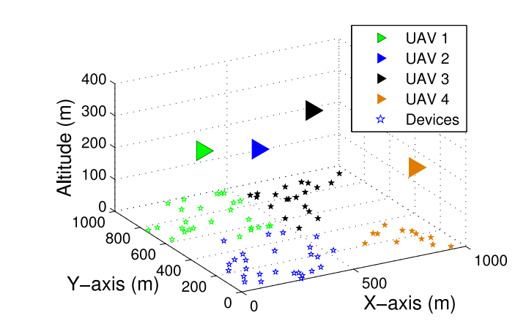

UAV should be placed near to the ground device which has poor link quality to UAV. We’ve derived this optimal 3D position using optimization theory and device-UAV association such that total uplink transmit power of devices is minimized. So devices will be able to send their data t the associated UAVs using minimum total transmit power.

Challenges and open problems:

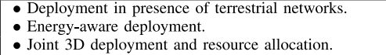

1. Trajectory Optimization

Optimizing the trajectory of UAVs is crucial for efficient UAV-based communication systems.The trajectory is affected by factors such as flight time, energy constraints, user demands, and collision avoidance.optimizing the flight path of UAVs is challenging due to physical constraints and parameters such as channel variation, dynamics, energy consumption, and flight constraints. In fact, prior studies on UAV trajectory optimization focused on three aspects: control and navigation, localization, and wireless communications. In particular, in the existing works on UAV communications, trajectory optimization was performed with respect to energy consumption, rate, and reliability.

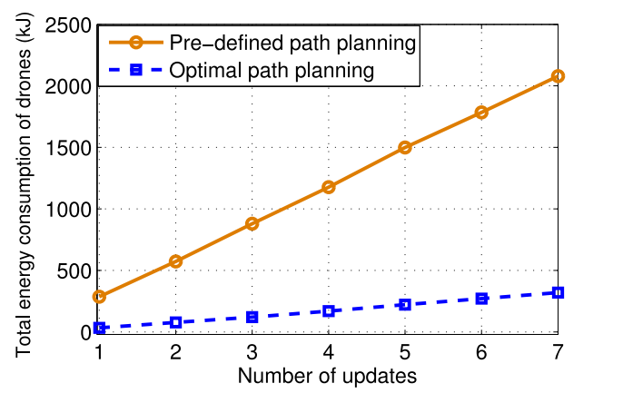

In time varying IoT network, let’s consider that the number of active IoT devices changes over time. So drone must update their location according to the location of the active IoT devices. The higher number of updates in position requires more mobility of drones, thus more energy consumption. So If we use an optimized path,as shown in figure, we can decrease the energy consumption by 74% compared to a non optimal case(predefined path).

Challenges and open problems:

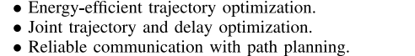

1. **Resource Management and Energy Efficiency :**

The deployment and operation of unmanned aerial vehicles (UAVs) in various applications require careful consideration of resource management and energy efficiency. UAVs face unique challenges due to their limited on-board energy, flight time, path planning, spectral efficiency, and LoS interference. These challenges require the optimization and management of resource allocation in complex UAV-assisted wireless networks operating over heterogeneous spectrum bands and co-existing with ground networks. To address these challenges, researchers and engineers are exploring techniques such as path planning, power management, spectrum sharing, cooperative communication, and energy harvesting. By adopting these techniques, UAV-assisted wireless networks can provide efficient and reliable communication services while meeting the energy and flight constraints of UAVs.

In general, the total energy consumption of a UAV is composed of two main components

1) Communication related energy

2) Propulsion energy.

The energy associated with communication is used for a variety of communication tasks, including signal processing, calculations, and signal transmission. The mechanical energy required by UAVs to move and hover is referred to as propulsion energy. Usually, the energy used for propulsion is far greater than the energy used for communication.

We provide some baseline propulsion energy consumption models for fixed-wing and rotary-wing UAVs in a forward flight with speed V.

**For a fixed-wing UAV :**

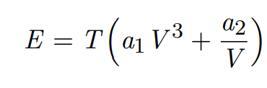

T = flight time

a1 and a2 = constants that depend on UAV’s weight, wing area, and air Density

**For a rotary-wing UAV :**

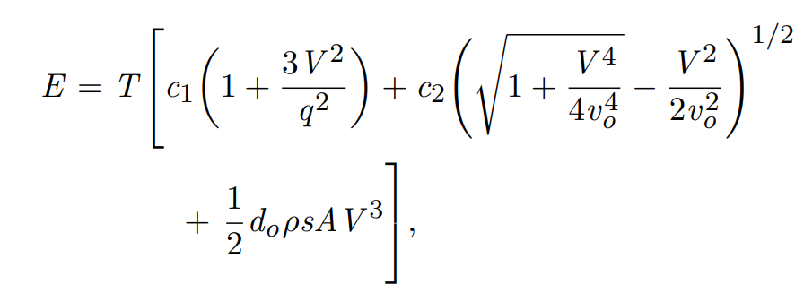

where c1 and c2 are constants which depend on drone’s weight, rotor’s speed, rotor

disc area, blade angular velocity, and air density. q is the tip speed of the rotor, do is

the fuselage drag ratio, vo is the mean rotor speed, ρ is air density, s is the rotor solidity, and A is the rotor disc area.

we considered a scenario in which 5 UAVs are deployed as aerial base stations over a rectangular area of size 1 km × 1 km in order to provide service for 50 ground users.

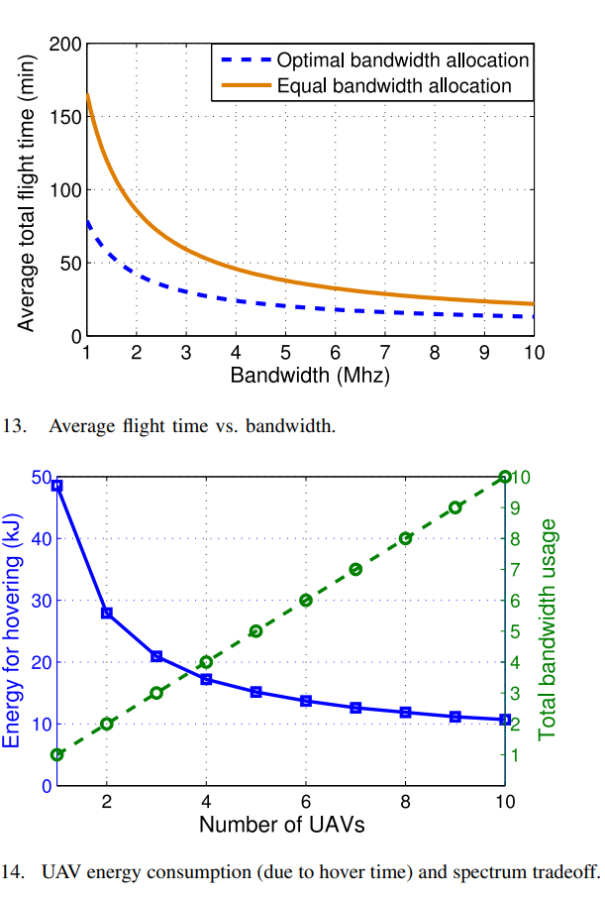

Graph des. :

Figure 13 shows the average total flight time of UAVs versus the transmission bandwidth. Here, the total flight time represents the time needed to provide service to all ground users, each of which requires a 100 Mb data. We consider two bandwidth allocation schemes, the optimal bandwidth allocation, and an equal bandwidth allocation. Clearly, by increasing the bandwidth, the total flight time that the UAVs require to service their users decreases. Naturally, a higher bandwidth can provide a higher transmission rate and, thus, users can be served within a shorter time duration.

Result :

From Figure 13, we can observe that the optimal bandwidth allocation scheme can lead to a 51% shorter flight time compared to the equal bandwidth allocation case. This is because, by optimally allocating the bandwidth to each user based on its load and location, the total flight time of UAVs can be minimized.

Graph des. :

we show the total hovering energy consumption of the UAVs as a function of number of UAVs. This result corresponds to the interference-free scenario in which the UAVs operate on different frequency bands. Hence, the total bandwidth usage linearly increases by increasing the number of UAVs. Clearly, the total energy consumption decreases as the number of UAVs increases. A higher number of UAVs corresponds to a higher number of cell partitions. Therefore, the size of each cell partition decreases and the users will have a shorter distance to the UAVs. Increasing the number of UAVs leads to a higher transmission rate thus shorter hover time and energy consumption.

Result :

Figure 14 shows that when the number of UAVs increases from 2 ot 6, the total energy consumption of UAVs decreases by 53%. Nevertheless, deploying more UAVs in interference-free scenario requires using more bandwidth. Hence, there is a fundamental tradeoff between the energy consumption of UAVs for hovering and bandwidth efficiency.

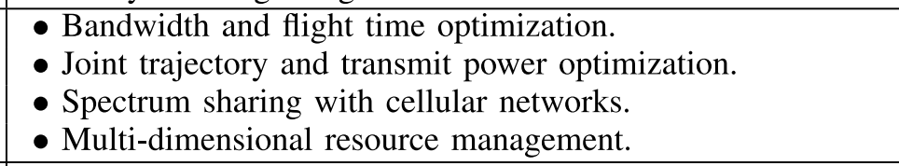

**U2U Communication:**

Reliable and direct communication between unmanned aerial vehicles (UAVs) could facilitate

1. autonomous flight

Using autonomous operation on UAV devices, we can guarantee collision avoidance, So that the UAVs can do self control of aerial traffic.

1. cooperation in UAV swarms

Single UAV has limited processing capacity, payload capacity and range of communication.To meet specific goals, a group of UAVs may work together as swarms.

1. **Aerial relaying:**

Use of U2U communication enables aerial relaying to extend the coverage of ground BSs and serve users in remote or disaster areas.

There are four different link types in a U2U communication system: UAV-to-UAV, UAV-to-BS, GUE-to-BS, and GUE-to-UAV, each with different propagation conditions. UAV-to-UAV links are mostly in LoS conditions. While LoS propagation conditions facilitate stronger signals, they may also lead to stronger interference to/from other UAVs and ground communications, suggesting the need for revisiting the design of D2D cellular communication for aerial devices.

**Impact of the UAV altitude:**

The impact of the UAV altitudes on SINR performance of GUEs and UAVs is shown in figure. The graph shows that the UL performance of GUEs degrade in the presence of U2U link due to interference generated by aerial devices.

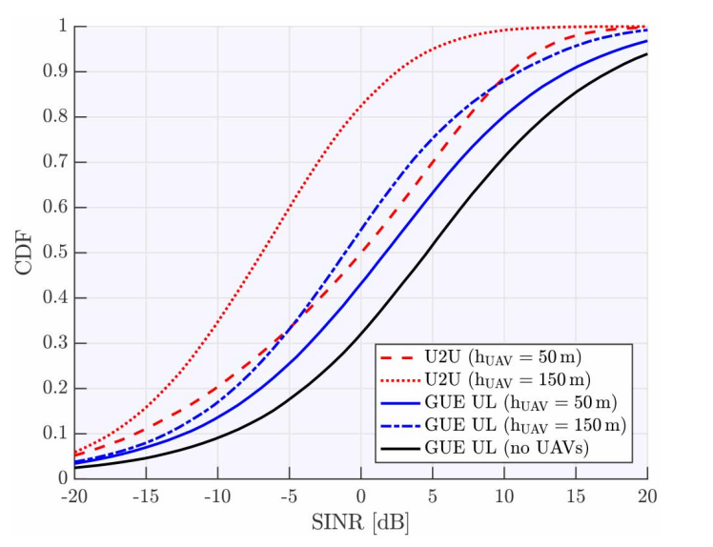

1. **Simulation of UAV Communication -Utsav**

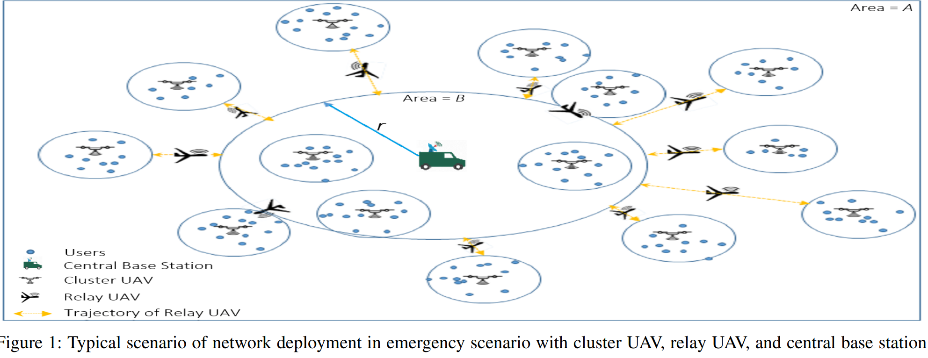

We have used the scenario of network deployment with cluster UAV, relay UAV and central BS.

As we can see, we use relay UAVs for the cluster UAVs which are outside the range of the central BS. The cluster UAVs are static in the horizontal direction and The relay UAVs are static in the vertical direction.

Here, we have assigned cluster UAVs to each cluster of population.

These relay UAVs assist central UAVs for better coverage, data-offloading. They provide wireless coverage between ground BS and cluster UAVs.

Using relay UAVs, we can maximize the total throughput of wireless devices connected to the cluster UAVs.

In our simulation, we have created users using the multivariate gaussian distribution. We placed the ground BS at the center of the mean of the centroids.

Here is the random placement of the cluster UAVs.

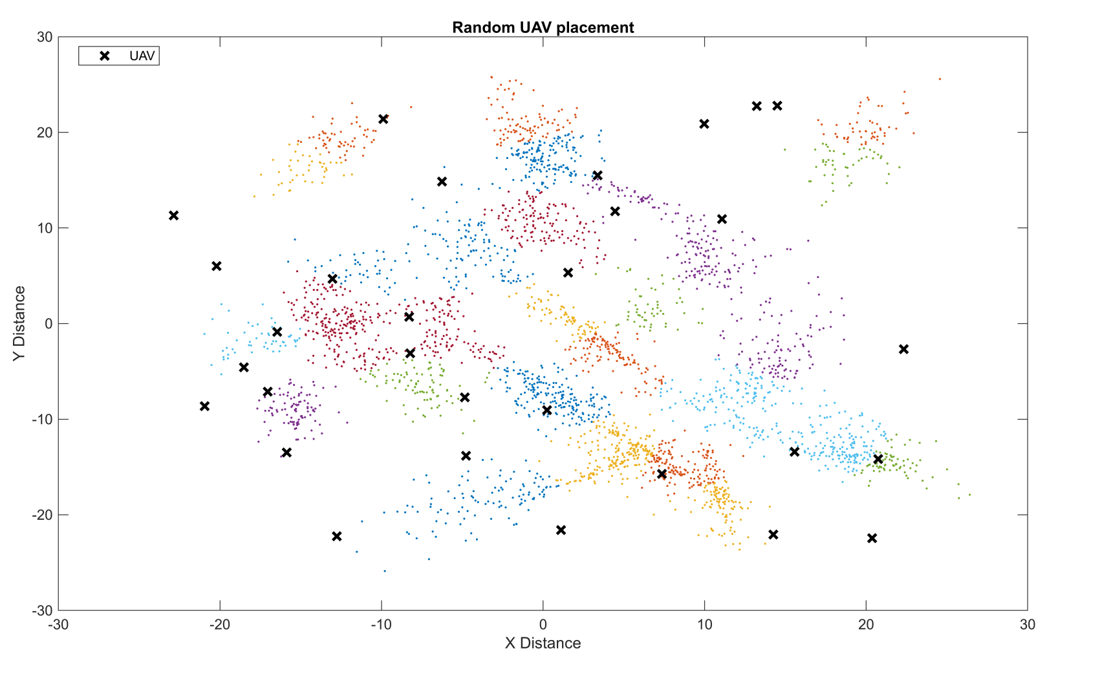

Then, using the K-means algorithm, we assigned a cluster UAV for each of the clusters.

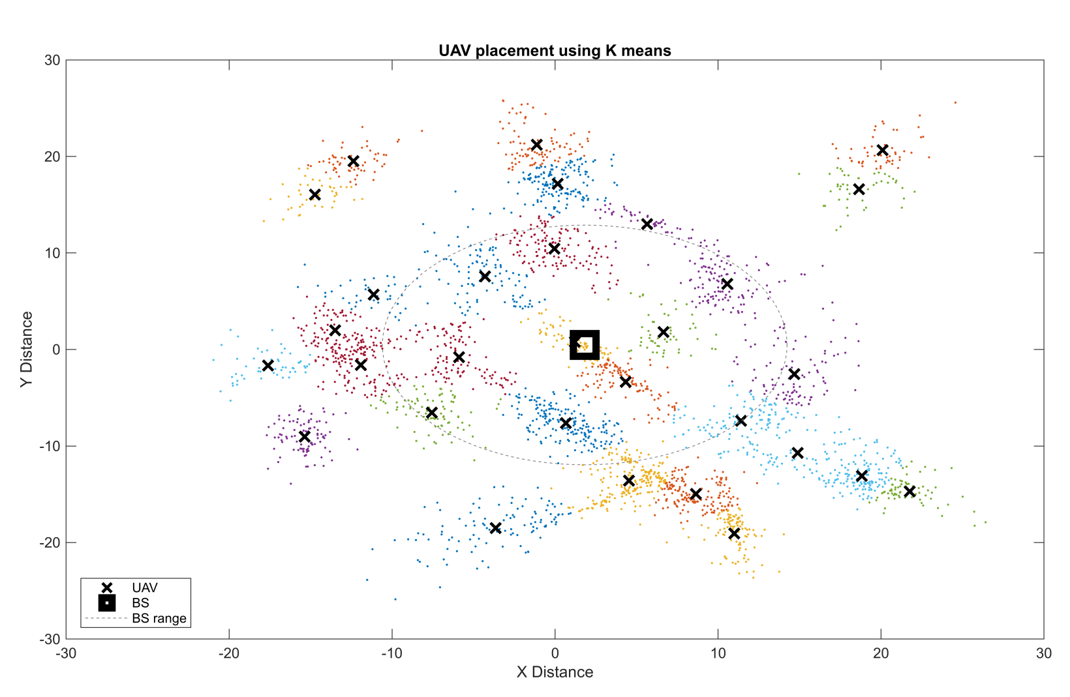

We have used these equations to determine the optimal height, power.

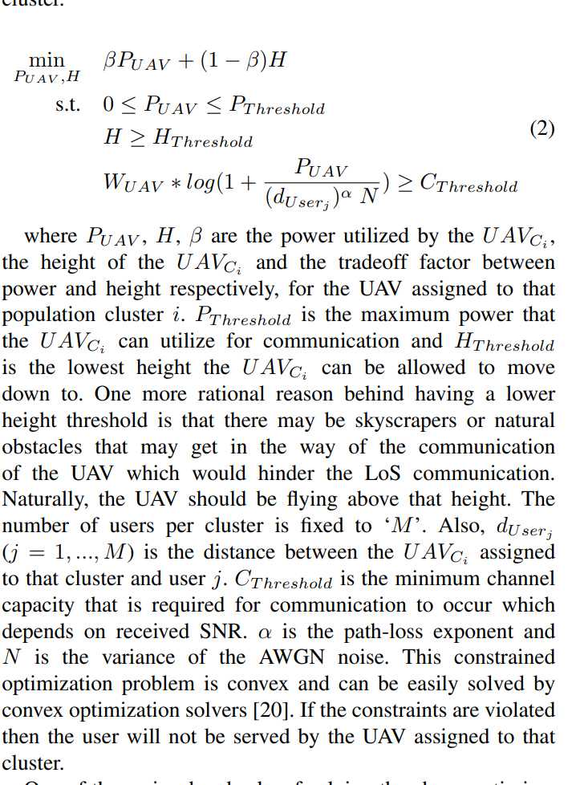

We have used these equations to determine the optimal position of the relay UAVs.

The equations are,

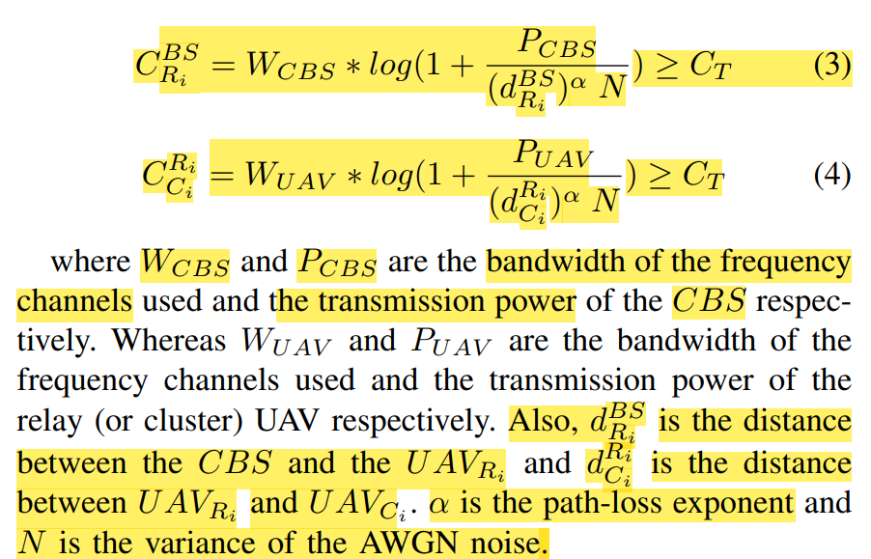

After applying these equations, we can get the location of relay uavs as,

